Akhilanand Sirra (002197798)

**Program Structures & Algorithms**

**Fall 2021**

**Assignment No. 2**

**Task**

* (Part 1) Implement three methods of *Timer.java* & check implementation by running the unit tests in *BenchmarkTest.java*and*TimerTest.java*
* (Part 2) Implement *InsertionSort* (in the *InsertionSort* class) & check implementation by running the unit tests in *InsertionSortTest*
* (Part 3) Implement a main program to run the following benchmarks: measure the running times of this sort, using four different initial array ordering situations: random, ordered, partially-ordered and reverse-ordered.
* Use the doubling method for choosing *n* and test for at least five values of *n.*
* Draw conclusions from the observations regarding the order of growth.

**Relationship Conclusion:**

The order of growth of the running time of Insertion Sort (Randomly ordered array of size *N*) is .

The order of growth of the running time of Insertion Sort (Ordered array of size *N*) is .

The order of growth of the running time of Insertion Sort (Partially ordered array of size *N*) is .

The order of growth of the running time of Insertion Sort (Reverse ordered array of size *N*) is .

In terms of order of growth, the running time of Insertion sort arranged in ascending order

**Evidence to support the conclusion:**

Let be the running time of Insertion sort for numbers

Using the doubling method, we can generate a sequence of random input arrays, doubling the array size at each step, and print the running times of Insertionsort() for each input size of different ordering situations.

**Random Ordered Array**

Here, we took the initial input size of the array as 1000, kept increasing it till 16000, and measured the running time of the insertion sort algorithm for a randomly ordered array.

|  |  |  |  |  |
| --- | --- | --- | --- | --- |
| **Array Length** | **Time** | **lg(Array Length)** | **lg(Time)** | **Slope** |
| 1000 | 3.04 | 9.965784285 | 1.604071324 | - |
| 2000 | 7.2 | 10.96578428 | 2.847996907 | - |
| 4000 | 29.28 | 11.96578428 | 4.871843649 | 2.0238467 |
| 8000 | 110.36 | 12.96578428 | 6.786073552 | 1.9142299 |
| 16000 | 494.04 | 13.96578428 | 8.948484044 | 2.1624105 |
|  |  |  | Avg Slope= | 2.0334957 |

**Analysis of experimental data (the running time of insertion sort with random ordered input)**

The below diagrams show the result of plotting the above table data, both on a standard and a log-log scale, with the input size on the and the running time on the .

**Standard Plot: problem size N vs running time T(n)**

By looking at the plots we can lead to hypothesis that the function ) is in form of

Where,

N = input size

a = machine dependent constant

b = slope of the log-log scale graph

**Log-Log Plot: lg N vs lg(T(n))**

The log-log plot of the above computed data leads to a hypothesis that it fits a straight line of slope 2 on the log-log plot. The data above in the table indicates that the average slope was found to be ~2.0334.

The equation of such a line is

Which is equivalent to,

**Ordered Array**

|  |  |  |  |  |
| --- | --- | --- | --- | --- |
| **Array Length** | **Time** | **lg(Array Length)** | **lg(Time)** | **Slope** |
| 1000 | 0 | 9.965784285 | - | - |
| 2000 | 0 | 10.96578428 | - | - |
| 4000 | 0 | 11.96578428 | - | - |
| 8000 | 0.04 | 12.96578428 | -4.64385619 | - |
| 16000 | 0.08 | 13.96578428 | -3.64385619 | 1 |
|  |  |  | Avg Slope= | 1 |

**Analysis of experimental data (the running time of insertion sort with an ordered input)**

Here, we took the initial input size of the array as 1000, kept increasing it till 16000, and measured the running time of the insertion sort algorithm for an ordered array.

**Standard Plot: problem size N vs running time T(n)**

**Log-Log Plot: lg N vs lg(T(n))**

The log-log plot of the above computed data leads to a hypothesis that it fits a straight line of slope 1 on the log-log plot. The data above in the table indicates that the average slope was found to be ~1.

The equation of such a line is

Which is equivalent to,

When the ordering situation of the array is sorted, insertion sort takes the linear time to run. As it takes compares and exchanges.

**Partially Ordered Array**

|  |  |  |  |  |
| --- | --- | --- | --- | --- |
| **Array Length** | **Time** | **lg(Array Length)** | **lg(Time)** | **Slope** |
| 1000 | 0.88 | 9.965784285 | -0.184424571 | - |
| 2000 | 3.4 | 10.96578428 | 1.765534746 | 1.9499593 |
| 4000 | 14.16 | 11.96578428 | 3.82374936 | 2.0582146 |
| 8000 | 55.76 | 12.96578428 | 5.801158656 | 1.9774093 |
| 16000 | 243 | 13.96578428 | 7.924812504 | 2.1236538 |
|  |  |  | Avg Slope= | 2.0273093 |

**Analysis of experimental data (the running time of insertion sort with random ordered input)**

Here, we took initial input size of array as 1000 and kept increasing it till 16000 and measured the running time of the insertion sort algorithm for a partially ordered array.

**Standard Plot: problem size N vs running time T(n)**

**Log-Log Plot: lg N vs lg(T(n))**

The log-log plot of the above computed data leads to a hypothesis that it fits a straight line of slope 2 on the log-log plot. The data above in the table indicates that the average slope was found to be ~2.0273.

The equation of such a line is

Which is equivalent to,

**Reverse Ordered Array**

|  |  |  |  |  |
| --- | --- | --- | --- | --- |
| **Array Length** | **Time** | **lg(Array Length)** | **lg(Time)** | **Slope** |
| 1000 | 3.44 | 9.965784285 | 1.782408565 | - |
| 2000 | 14.04 | 10.96578428 | 3.811471031 | 2.0290625 |
| 4000 | 59.4 | 11.96578428 | 5.892391026 | 2.08092 |
| 8000 | 250.68 | 12.96578428 | 7.969703088 | 2.0773121 |
| 16000 | 1064.08 | 13.96578428 | 10.0553909 | 2.0856878 |
|  |  |  | Avg Slope= | 2.0682456 |

**Analysis of experimental data (the running time of insertion sort with random ordered input)**

Here, we took the initial input size of the array as 1000, kept increasing it till 16000, and measured the running time of the insertion sort algorithm for a reverse ordered array.

**Standard Plot: problem size N vs running time T(n)**

**Log-Log Plot: lg N vs lg(T(n))**

The log-log plot of the above computed data leads to a hypothesis that it fits a straight line of slope 2 on the log-log plot. The data above in the table indicates that the average slope was found to be ~2.0682.

The equation of such a line is

Which is equivalent to,

When the ordering situation of the array is reverse sorted, insertion sort takes the longest time to run. As it takes compares and exchanges.

**Console Output:**

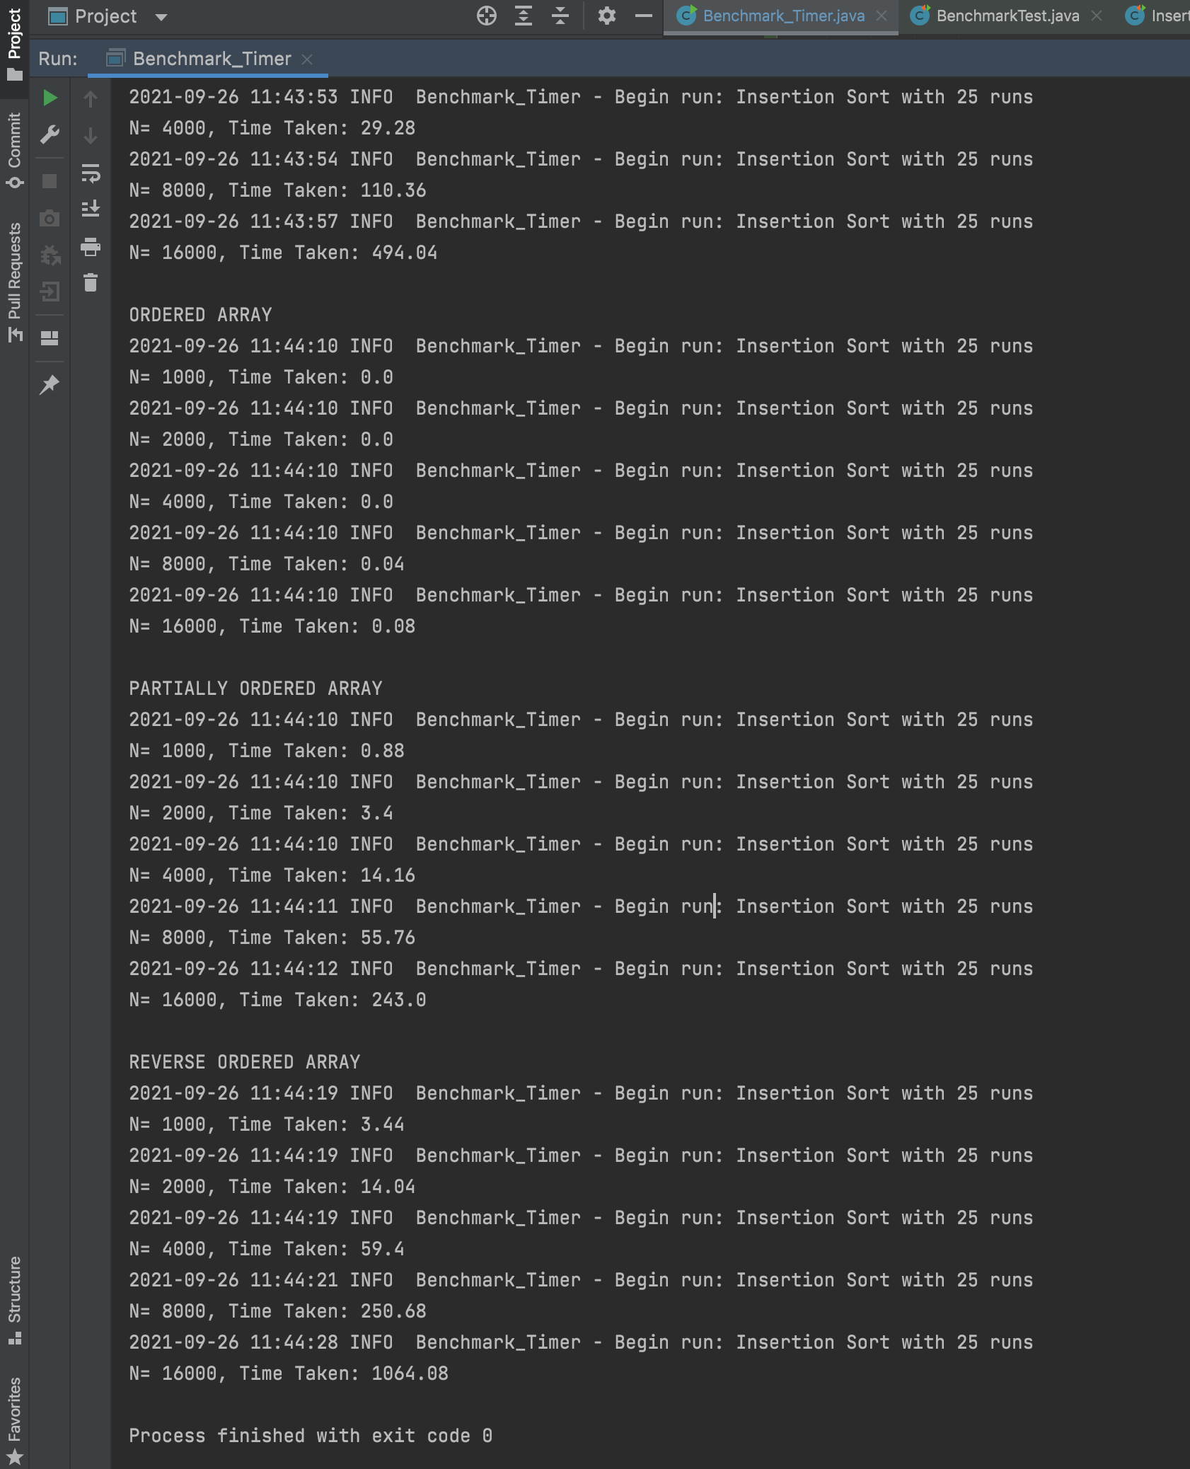

RANDOMLY ORDERED ARRAY

2021-09-26 11:43:52 INFO Benchmark_Timer - Begin run: Insertion Sort with 25 runs

N= 1000, Time Taken: 3.04

2021-09-26 11:43:53 INFO Benchmark_Timer - Begin run: Insertion Sort with 25 runs

N= 2000, Time Taken: 7.2

2021-09-26 11:43:53 INFO Benchmark_Timer - Begin run: Insertion Sort with 25 runs

N= 4000, Time Taken: 29.28

2021-09-26 11:43:54 INFO Benchmark_Timer - Begin run: Insertion Sort with 25 runs

N= 8000, Time Taken: 110.36

2021-09-26 11:43:57 INFO Benchmark_Timer - Begin run: Insertion Sort with 25 runs

N= 16000, Time Taken: 494.04

ORDERED ARRAY

2021-09-26 11:44:10 INFO Benchmark_Timer - Begin run: Insertion Sort with 25 runs

N= 1000, Time Taken: 0.0

2021-09-26 11:44:10 INFO Benchmark_Timer - Begin run: Insertion Sort with 25 runs

N= 2000, Time Taken: 0.0

2021-09-26 11:44:10 INFO Benchmark_Timer - Begin run: Insertion Sort with 25 runs

N= 4000, Time Taken: 0.0

2021-09-26 11:44:10 INFO Benchmark_Timer - Begin run: Insertion Sort with 25 runs

N= 8000, Time Taken: 0.04

2021-09-26 11:44:10 INFO Benchmark_Timer - Begin run: Insertion Sort with 25 runs

N= 16000, Time Taken: 0.08

PARTIALLY ORDERED ARRAY

2021-09-26 11:44:10 INFO Benchmark_Timer - Begin run: Insertion Sort with 25 runs

N= 1000, Time Taken: 0.88

2021-09-26 11:44:10 INFO Benchmark_Timer - Begin run: Insertion Sort with 25 runs

N= 2000, Time Taken: 3.4

2021-09-26 11:44:10 INFO Benchmark_Timer - Begin run: Insertion Sort with 25 runs

N= 4000, Time Taken: 14.16

2021-09-26 11:44:11 INFO Benchmark_Timer - Begin run: Insertion Sort with 25 runs

N= 8000, Time Taken: 55.76

2021-09-26 11:44:12 INFO Benchmark_Timer - Begin run: Insertion Sort with 25 runs

N= 16000, Time Taken: 243.0

REVERSE ORDERED ARRAY

2021-09-26 11:44:19 INFO Benchmark_Timer - Begin run: Insertion Sort with 25 runs

N= 1000, Time Taken: 3.44

2021-09-26 11:44:19 INFO Benchmark_Timer - Begin run: Insertion Sort with 25 runs

N= 2000, Time Taken: 14.04

2021-09-26 11:44:19 INFO Benchmark_Timer - Begin run: Insertion Sort with 25 runs

N= 4000, Time Taken: 59.4

2021-09-26 11:44:21 INFO Benchmark_Timer - Begin run: Insertion Sort with 25 runs

N= 8000, Time Taken: 250.68

2021-09-26 11:44:28 INFO Benchmark_Timer - Begin run: Insertion Sort with 25 runs

N= 16000, Time Taken: 1064.08

Process finished with exit code 0

**Unit tests result:**

TimerTest.java

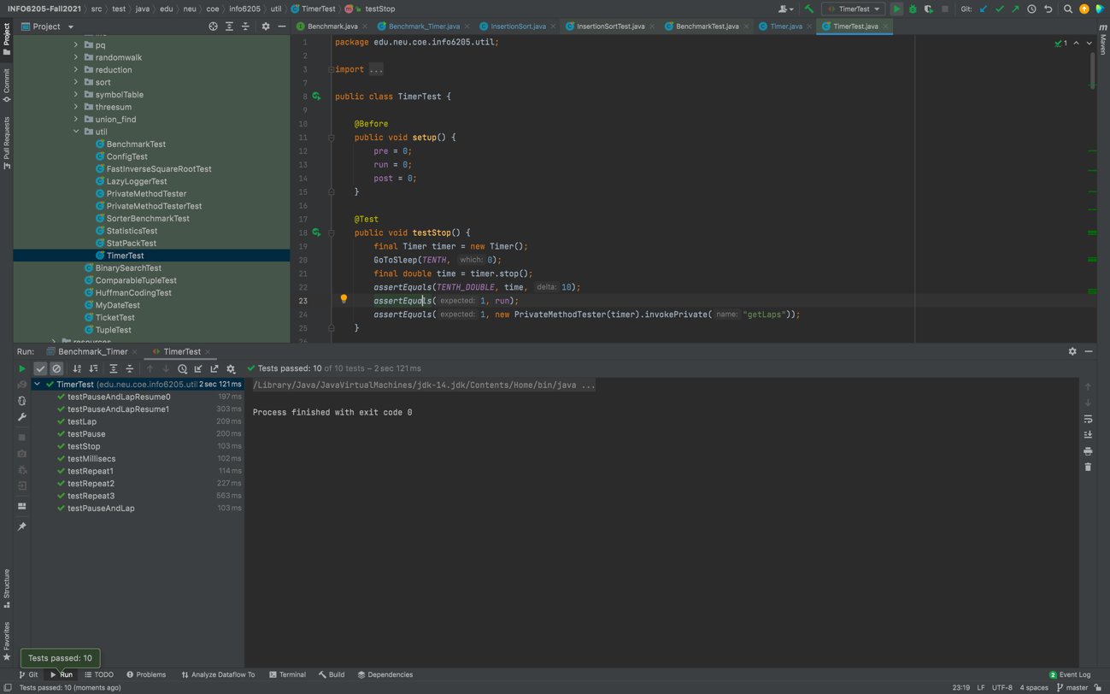

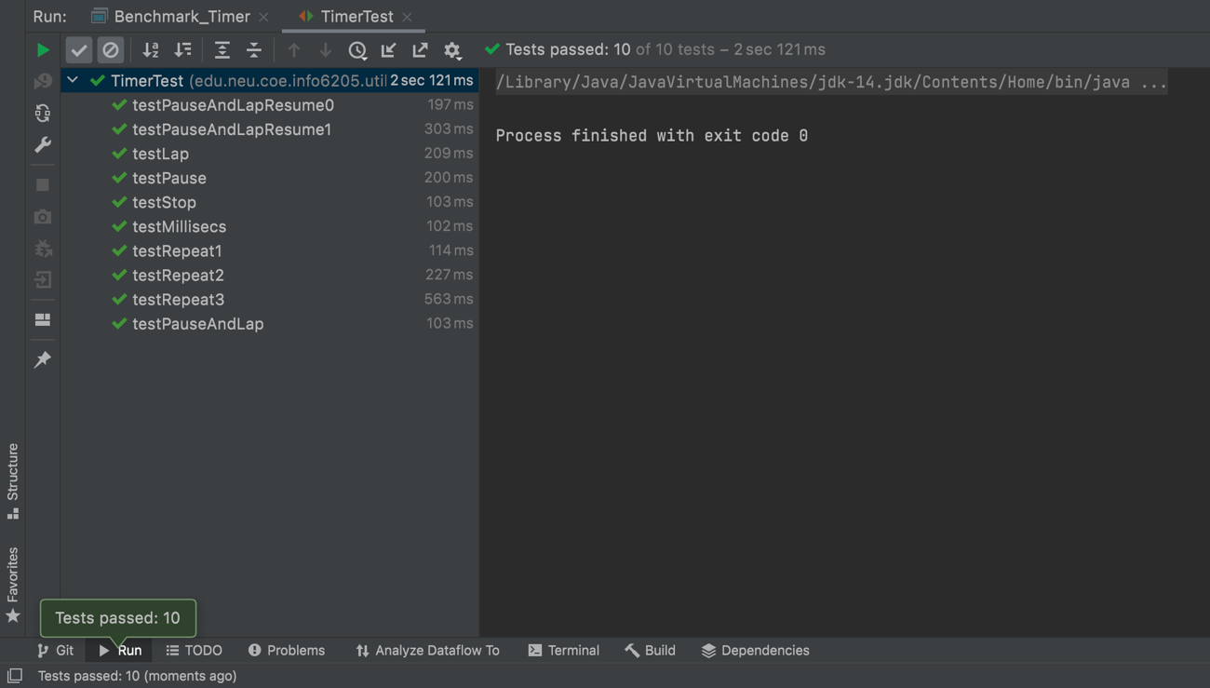

BenchmarkTest.java

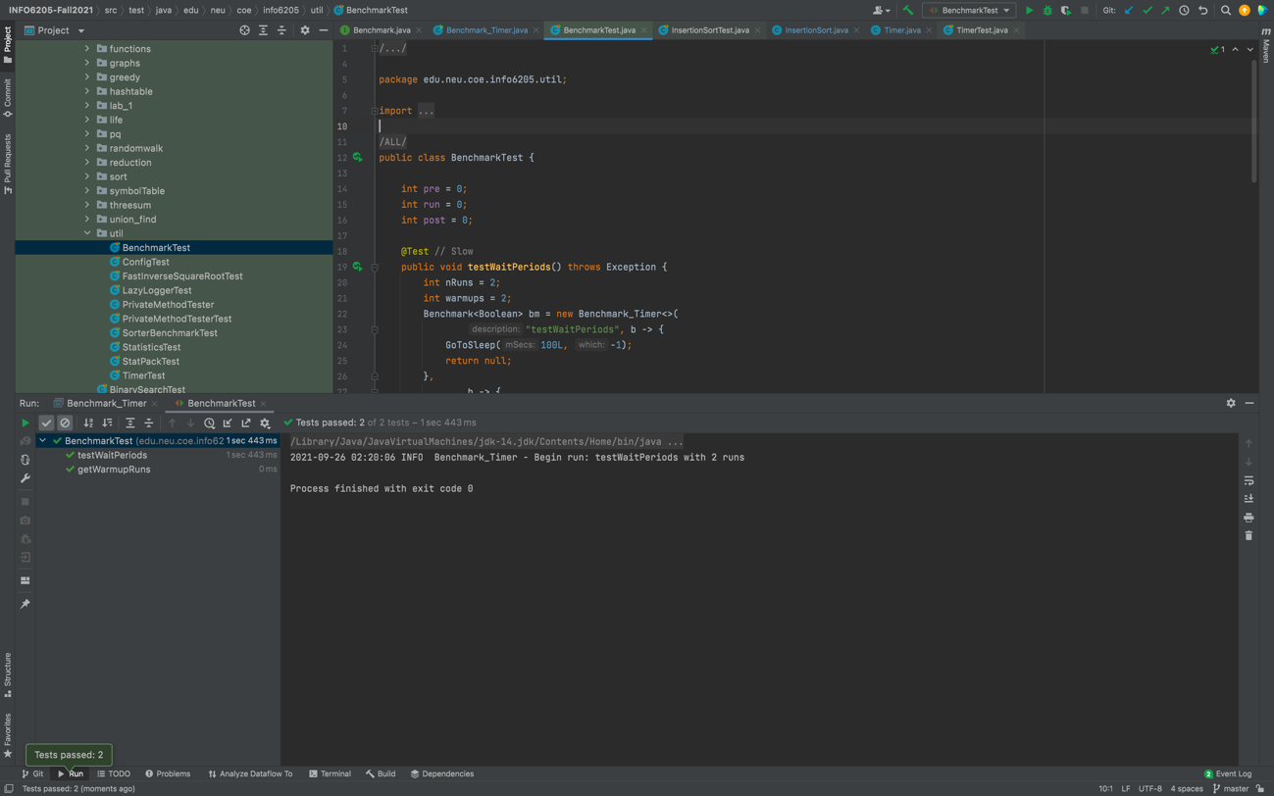

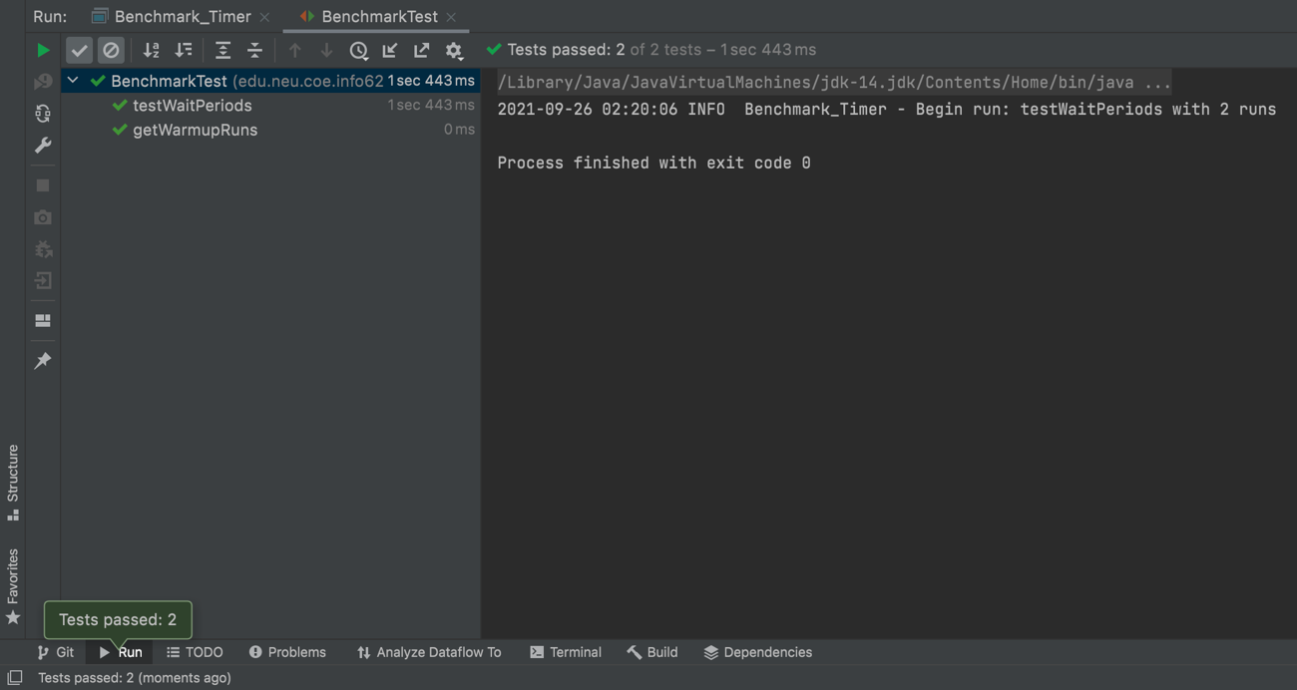

InsertionSortTest.java

